LC#73:SET MATRIX ZEROS
Given an m x n integer matrix matrix, if an element is 0, set its entire row and column to 0's.
You must do it in place.

Example 1:
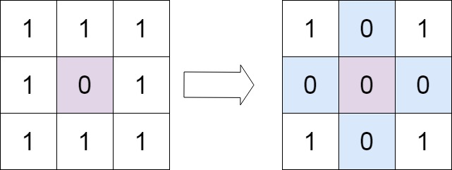
Input: matrix = [[1,1,1],[1,0,1],[1,1,1]]
Output: [[1,0,1],[0,0,0],[1,0,1]]
APP1 :
class Solution {
public void setZeroes(int[][] m) {
int row = m.length;
int col = m[0].length;

boolean isFirstRowZero = false;
boolean isFirstColZero = false;

for(int i = 0 ; i< col ; i++)
{
if(m[0][i] == 0)
{
isFirstRowZero = true;
break;
}
}

for(int i = 0 ; i < row ; i++)
if(m[i][0] == 0)
{
isFirstColZero = true;
break;
}

for(int i = 1 ; i< row ; i++)
{
for(int j = 1; j< col ; j++)
{
if(m[i][j] == 0)
{
m[i][0] = 0;
m[0][j] = 0;
}
}
}

for(int i = 1 ; i< row ; i++)
{
for(int j = 1 ; j< col ; j++)
{
if(m[i][0] == 0 || m[0][j] == 0)
m[i][j] = 0;
}
}

if(isFirstRowZero)
{
for(int i = 0 ; i<col ; i++)
m[0][i] = 0;
}

if(isFirstColZero)
{
for(int i = 0 ; i<row ; i++)
m[i][0] = 0;
}

}
}

